Why is it so hard to get a GP appointment?
Amid record delays for getting NHS GP appointments, we look into what's gone wrong and how to get help when you need it

Ian AikmanSenior researcher & writer

It’s 7:58am and my finger is hovering over my phone screen. If I tap ‘call’ in one minute 30 seconds, I’ll have a good chance of being near the front of the queue. I tap. Too early. The pre-recorded message tells me the line still isn’t open. I hang up and redial. It’s now open, but there are 15 callers ahead of me. I leave my phone on loudspeaker and get ready for the jangly hold music to soundtrack my morning.
Most of us will have experienced this frustrating 8am scramble. Getting a GP appointment isn’t as easy as it used to be, and satisfaction with making appointments is at a historic low.
Between 2021 and 2022 there was a sharp decline in patients who had a good experience making an appointment, from 71% to 56%, according to the latest NHS data.
Appointments don’t always come quickly either. While nearly 12 million patients were seen same-day in September 2022, more than 5m appointments took place at least two weeks after patients booked them.
I wanted to find out how and why we’ve ended up with a system nobody seems to like, and whether there’s a way it could work better. So I spoke to dozens of patients and health experts, and visited Haughton Thornley Medical Centre in Hyde, Greater Manchester, where I spent a day with GP partner Dr Amir Hannan (pictured below) and the staff who run the practice.

Appointment booking process leaves patients stressed and frustrated
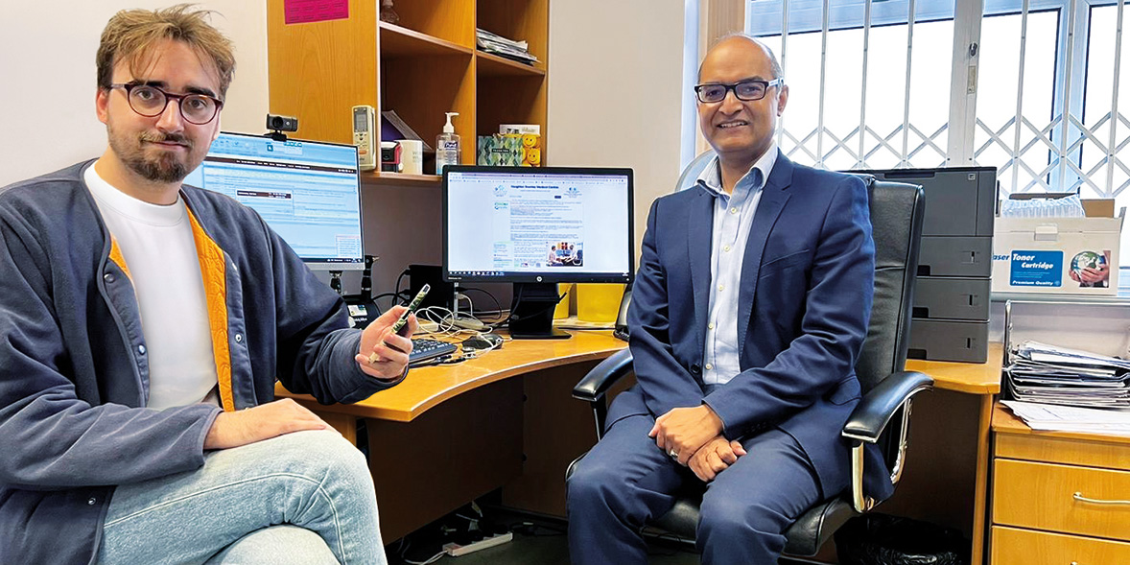
Which? reporter Ian Aikman with Dr Amir Hannan, GP
"Getting fed up with it. You cannot see the doctor when you need to, so you keep putting it off while the issue only gets worse."*
Thousands of patients shared their experiences of accessing GP appointments with us in a survey, and ‘frustrating’ and ‘stressful’ were recurring themes. One summed it up bluntly: ‘I think the GP needs a kick up the arse. They’re dragging their feet.’
But GPs don’t go through years of training just to dodge appointments. I spoke to several former and current GPs for this story, and all of them expressed similar frustrations at the problems facing primary care.
Hear a first-hand account of what it is like being a front-line GP as we visit the surgery to see just what it's like at such a difficult time for the NHS.

Not enough GPs to cope with patient backlog
Haughton Thornley Medical Centre receives up to 500 calls a day once the lines open at 8:00am. The day’s appointments are usually booked up within 20 minutes, at which point the receptionists – officially known as ‘patient advisers’ – spend their time finding other ways to help.
‘The number of phone calls coming in is absolutely phenomenal,’ said Rachel Hirst, Haughton Thornley’s practice manager. ‘You’ve got to keep morale up.’ I spot a motivational poster taped to the receptionists’ office wall: ‘Don’t let difficult times make you forget your blessings.’
It’s definitely a difficult time for the NHS. At the heart of the problem is a shortage of GPs; the workforce decreased by 4% between 2017 and 2022, while the patient population has only grown. Droves of doctors have quit or reduced their working hours amid intense work pressures exacerbated by the pandemic.
Even just observing Dr Amir Hannan’s workload during my near-12-hour day with him was exhausting, and that’s not including the additional hours of paperwork he did both before and after our time together.
He loves seeing his patients get better, and he’s full of enthusiasm. But dedication alone can’t keep the system afloat. Other GPs told us they have such a heavy workload that they worry it’s unsafe – for patients and for doctors.

The search for a system-wide solution
Problems with getting a GP appointment are only one piece of the jigsaw.
In September, Downing Street said 400,000 people were waiting more than a year for operations, compared to just 1,600 before Covid-19. The knock-on effect of this vast backlog sees patients return to their GPs to manage their conditions while they wait.
Dr Richard Van Mellaerts, deputy chair of the British Medical Association’s (BMA) England GP committee, told me about what healthcare staff call ‘moral injury’ – the pain that comes from being unable to provide care to a standard they’d like.
‘There are too few GPs in England,’ he said. ‘And those that are there are exhausted. They’re working harder and harder, but it’s an impossible task at the moment. So we need a system-wide solution from the NHS in order to fix this.’

Why you might not see your GP - and that's not always a bad thing
To offset the GP shortage, some GP practices are thinking laterally, assembling broader teams of medical professionals - including nurses, pharmacists, paramedics and musculoskeletal practitioners (MSKs).
Haughton Thornley’s MSK specialist sees 19 patients a day. When I stop by his office on a tour of the practice, I ask him if patients are happy to see him, or if they’d rather see a GP. They’re mostly satisfied, he says. But only after he explains that, as a specialist, he’s actually better equipped to help.
It’s the same with other specialists, says Dr Hannan. A pharmacist, for example, is more suited for a medication review. GPs don’t have more expertise in these areas than specialists do. In fact, they sometimes have less.

Why GP receptionists ask about your issue
It’s the job of the receptionists to help patients see the expert best suited to them. But patients can see them as gatekeepers blocking their access to GPs – or fobbing them off.
Haughton Thornley’s complaints officer, Lorraine Hall, says people sometimes see receptionists as ‘dragons’. People particularly take issue with a recent development: receptionists asking what they’re calling about.
‘We don’t ask these questions because we’re being nosy. It’s because we’ve been told by the doctors that this is what we need to ask.’
I witnessed Dr Hannan having to use his time carefully, using details provided by the reception team to decide who needs to come to the practice, and who could be well served with a phone call or by a trainee doctor.
Lorraine says it can be difficult dealing with patients who won’t answer their questions. ‘Sometimes they get quite nasty,’ she said. We heard from a GP in another practice where two new receptionists quit within a week.
When I ask a roomful of receptionists at Haughton Thornley what patients could do to make life easier for them, without hesitation one of them says: ‘Remember we’re human, too.’
Still, this doesn’t change the fact that some patients find the process of telling receptionists about their health off-putting. The Patients Association suggests that establishing competency-based training for receptionists, based around responding to patients with kindness, could go some way to allay these concerns.
Being prepared for the question and having an answer ready that best describes your concern is one way you can minimise the stress too. It can help to write down the key things you want to mention.

Online booking and telemedicine barriers for some
"It’s a minimum 30-minute wait to get through. I only got an appointment because there had just been a cancellation. I was suffering and needed to be seen sooner really but I was lucky to get the appointment I did."
Patients have other issues with the way they book appointments, too. The lockdown-inspired drive towards online booking systems shuts out those who aren’t good with, or don’t have access to, technology.
Of the patients who did book online, less than half (49%) had a good experience, compared to 55% over the phone, according to the NHS. So it’s no surprise an overwhelming majority still book appointments over the phone.
This may also be because calling is usually the best way to get seen more promptly. But a phone-based same-day booking system is onerous time-wise, and inconvenient for those with inflexible work or caring responsibilities.
Part of the problem, says Dr Kartik Modha, a private GP who used to work for the NHS, is that access is being prioritised over continuity of care (seeing the same GP), despite studies showing continuity increases life expectancy for patients. The BMA’s Dr Van Mellaerts says the NHS is currently very focused on collecting data, some of which amounts to ‘box-ticking’. This, he says, is ‘distracting from care’.

How pharmacies can help
Freeing up GPs from more minor concerns could also help, and this is where pharmacies (and patients) can play a part.
Pharmacists can advise on a range of medication and health issues and also help patients navigate other NHS services. But despite the NHS running multiple campaigns advising patients to consult their pharmacies, just 32% of the 2,000 people Which? surveyed had done this.
Pharmacists say they have given more consultations since Covid hit, but they’re still an underused resource for patients.
The catch is, they can’t always prescribe things themselves. This can lead patients round in circles, getting advice from pharmacists, booking GP appointments to get prescriptions, then returning to the pharmacies to collect their medicine. To reach their true ‘healthcare hub’ potential, Thorrun Govind, England board chair of the Royal Pharmaceutical Society, says more pharmacists need to become independent prescribers.
However, some pharmacists have also raised concerns about additional workload pressures, and picking up the fall for a faltering NHS.

How can the system improve?
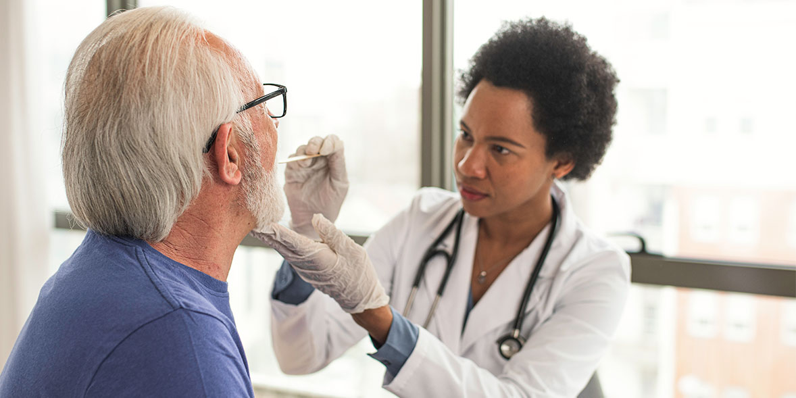
Everyone I spoke to agreed that the NHS – and primary care in particular – needs more funding. It’s almost become a cliché to say it, but that doesn’t make it any less true.
Many of the healthcare professionals I interviewed also said things would work better if patients were more informed about alternatives to GP services that they can call upon.
And while the recently published NHS-commissioned Fuller report into primary care advocates for a more joined-up system that brings together different local health services to improve efficiency, there are limits to what can be done without addressing wider and more immediate problems, such as staff shortages.
One Haughton Thornley receptionist told me the practice’s current booking system would be the best they’d had in decades, if they just had more doctors and fewer patients.

How to get help when you need it
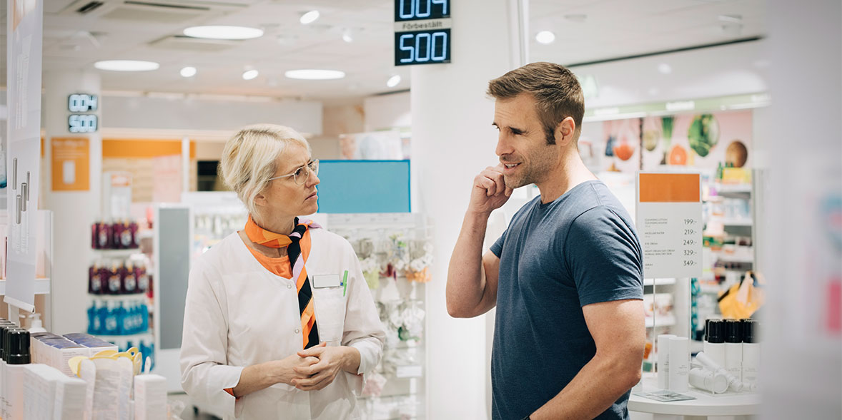
From the pandemic to the current relentless news cycle of NHS winter crises, there are plenty of reasons you might have put off getting help for niggling health issues in the last few years. It's better to seek help early on though, and potentially prevents a bigger problem down the line - for you and the NHS. So here's how to get started:

1. Get to know the best way to book
For non-urgent issues, see if you can book online via your practice’s website, or through a smartphone app like Patient Access or Evergreen Life. Your practice should be able to demonstrate how to download and use them if you're having issues.
There could be other ways to engage with your surgery more efficiently – check its website for email addresses or alternative phone numbers you can call for specific needs and ask the receptionists for advice on the best times or days to call.

2. Use online services
The NHS website has help and guidance on many medical conditions, although it often suggests visiting your GP if you have certain symptoms.
You can also check other online resources like Patient UK. The NHS 111 service can be a useful source of advice if you aren’t sure how urgent your problem is. You can use the online help tool, or call 111 directly.
Charity websites or phonelines can also advise you for certain conditions. Just make sure you stick to known companies and registered charities.

3. Make use of local alternatives
Pharmacists can help with minor ailments such as coughs, colds and stomach troubles; questions about medication; travel health advice and blood pressure monitoring. You can request a private consultation room if you need one.
Self-referral is an option for some NHS services, such as physio, mental health and podiatry treatment. Check your local NHS trust’s website to find out what’s available in your area.

4. Don’t give up
Be persistent – don’t lose faith and leave a problem to get worse. It’s best to contact your GP early rather than waiting until you’re in crisis.
If you consistently can’t get an appointment, consider your options, such as checking other nearby surgeries you could switch to (see the NHS’s Find a GP page) and how they're rated by patients.
To complain about your GP surgery, contact it directly or call your area’s free Patient Advice Liaison Service (PALS).

*Responses from a Which? survey with Opinium of 2,000 UK adults, weighted to be nationally representative and conducted 8-11 November 2022

