You could get help to buy fruit, vegetables, pulses,

milk and infant formula.

**www.healthystart.nhs.uk**

@NHSHealthyStart

**Are you pregnant or do you have**

**children under the age of four?**

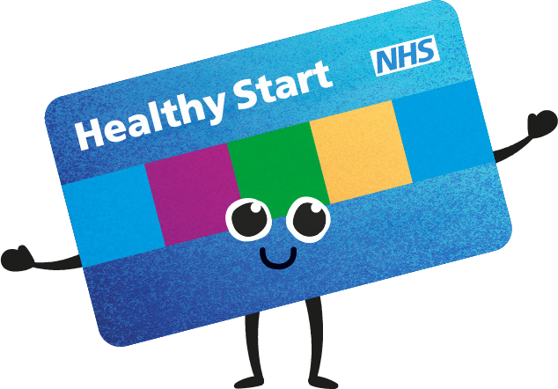

You could also get free Healthy

Start vitamins.

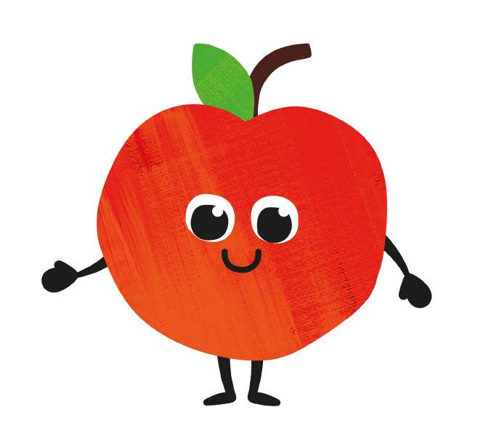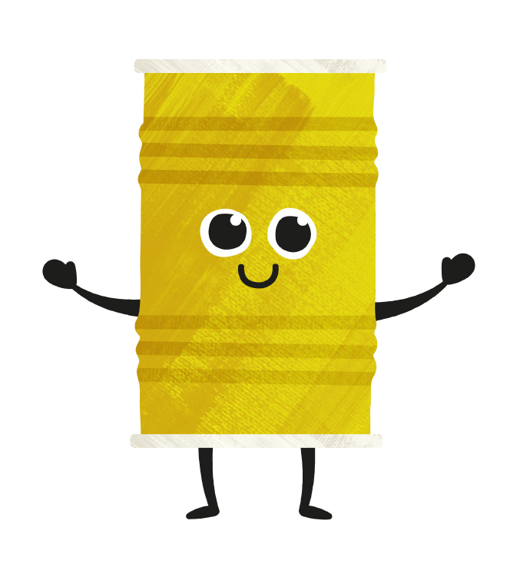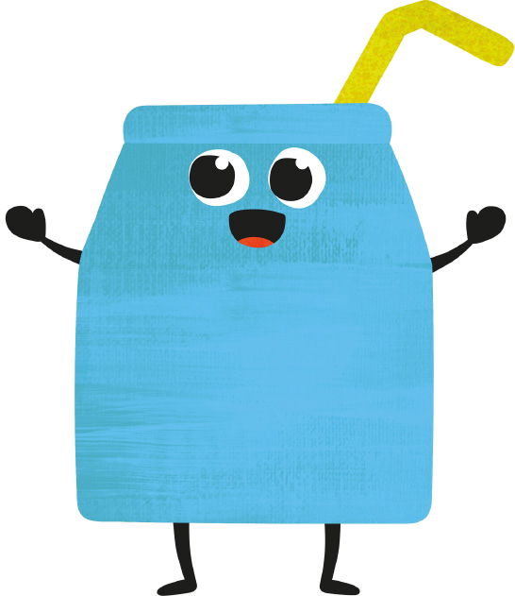

**Ydych chi'n feichiog neu oes gennych**

**blant o dan 4 oed?**

Gallech gael help i brynu Ffrwythau, llysiau, Codlysiau,

llaeth a llaeth fformiwla i fabanod.

Gallwch hefyd gael fitaminau

Healthy Start am ddim.

**Sganiwch Fi**

**Scan Me**

